SOFTWARE REQUIREMENTS SPECIFICATION

Telecommand Software 2.1

GEOSAT RF & Payload Checkout Division-2
Spacecraft Checkout Group

JULY 2020

UR RAO SATELLITE CENTRE
INDIAN SPACE RESEARCH ORGANISATION
BANGALORE

AUTHENTICATION

 | Name | Signature | Date
Prepared By | Janardhana Reddy G
Reviewed By | --
Approved By | M.S. Bhuvaneswari

CHANGE HISTORY

Version Number | Date | Affected Section, Figure, Table | Nature of change [A,M,D] * | Descriptiosssn
2.0 | 1-11-2017 | - | New
2.1 | 01-07-2020 |  | A | New Feature Requirements added

* A – Addition, D – Deletion, M-Modification

TABLE OF CONTENTS

Contents
1. Introduction 7
1.1 Purpose 7
1.2 Scope 8
1.3Definitions, Acronyms and Abbreviations 8
1.3.1 Definitions 8
1.3.2 Acronyms &Abbreviations 8
1.4 References 9
1.5 Overview of the document 9
2. Overall Description 10
2.1 Product Perspective 10
2.2 Product Functions 10
2.3 Constraints 11
2.4 Assumptions and Dependencies 11
2.5 Apportioning of requirements 12
3. Specific Requirements 12
3.1 External Interface Requirements 12
3.1.1 Spacecraft Checkout Computer 12
3.1.2 User Interfaces 12
3.1.3 Software Interfaces 12
3.2 Functional Requirements 13
3.2.1 Database tables for Telecommands 13
3.2.2 Provision to send tele-commands 15
3.2.3 Provision to trigger file execution. 15
3.2.4 Provisionto send configuration based BOA. 16
3.2.5 Provision to send required BOA manually. 16
3.2.6 Provision to send configuration based commands. 17
3.2.7 Search option to select commands or files 17
3.2.8 Provision should be there for command grouping 17
3.2.9Application should be accessible from any PC in the network 17
3.2.10 Safe re-configuration of payload from any current state to any another state shall be available. On/off sequencing shall be taken care. 17
3.2.11GUI interface shall be there to show current state of payload with switching complexity to change from current payload configurations to new configurations. 17
3.2.12Provision shall be there to generate test procedures document. 18
3.2.13Provision shall be there to exclude on commands while configuring the payload. 18
3.2.14Provision shall be there to set configuration based on test parameter. 18
3.2.15Provision shall be there to include call files along with other commands while setting configuration. 18
3.2.16Provision shall be there to inhibit tele-commands. 18
3.2.17Provision shall be there to limit the number of TWTAs /SSPAs to be switched on based on current limit and/or thermal requirement. 18
3.2.18Provision shall be there to keep adjacent channels at maximum BOA. 18
3.2.19 Provision to generate incremental procedure files 19
3.3. Performance Requirements 40
3.4. Design Constraints 40
3.5. Software System attributes 40
4. Requirements Traceability Matrix 42
5. Comparison of Featuresof all versions of TelecommandApplication 44

List of Tables
Table 1 Acronyms & Abbreviations 8
Table 2 References 8
Table 3 Telecommand Database Table 12
Table 4 Configuration based BOA database Table 12
Table 5 Telecommand files database table 12
Table 6 Data commands Database 13
Table 7 Data Commands Mapping Table 13
Table 8 Configuration based commanding database 14
Table 9 SCC Details 14
Table 10 Requirements Traceability 20
Table 11 Features Comparison 22

List of Figures
Figure 1 Telecommand software Package Interfaces 9
Figure 2 GUI for Tele-commands Drop down 14
Figure 3 GUI for selecting Tele-command Files 15
Figure 4 GUI for selecting BOA commands 15
Figure 5 GUI for Sending Data commands 15
Figure 6 GUI for sending configuration based commands 16

Introduction

1.1 Purpose

1.1.1 Brief overview of the existing Telecommanding Software ver1.0 & ver2.0

Prior to the characterization of Communication Payloads,they have to be commanded for setting up the required configuration. “Telecommanding Utilities” are one of the associated packages of COMPACSS meant for generation of payload telecommands based on users’ requirement & formatting them into a CCL-compatible file and transferring the same to SCC via ftp over LAN with UDP protocol with a request for execution. Following modes of telecommand(s) selection are supported.

Mode-1: Individual telecommand(s)

In this mode, user can select individual telecommand(s) from a drop-down list box and transmit them to SCC. The selected telecommands are formatted into a CCL-compatible file and transferred to SCC with a request for execution using an existing protocol between PCC &SCC. The telecommands are available in the database in MS-Access.

Mode-2: SCC-resident telecommand sequence file(s)

In this mode, the telecommand sequence files are already available in the SCC and the list of those filenames are available in the database in PCC. User can specify the file to be executed after which the PCC places a request with SCC for execution.

Mode-3: Configuration number(s)

In this mode, user selects only the configuration no(s) while the software picks up the corresponding telecommand(s) & telemetries from the database and formats them into CCL-compatible file and transfers it to SCC with a request for execution

This has greatly helped the test engineer to dynamically generate the command sequence files for the required configuration(s) on the Payload thereby reducing the preparation time as well as the execution time while avoiding manual errors. This was extensively used in all GEOSAT payload checkouts from INSAT-3A onwards upto GSAT-19. This was developed in Borland C++ 5.0 with WinAPI under Windows. The obsolescence of the development platform forced migration of the software into a new Telecommanding software 2.0 developed with python and vue XXXX vide SRS doc.
This version (ver 2.0) fulfilled some of the following limitations of ver 1.0
- When the total number of tele-commands is huge it is difficult & time-consuming to navigate through the list box to search & pick the required command.
- SEND TC is not preceded by the corresponding EXPECTED Tm in Mode-1.This limitation was not there in other Modes.
- Configuration will be set using incremental commanding, with this software will not check any constrains before turning on the payload. User must ensure sequence of configuration selection.
Additionally the following requirements were also fulfilled by ver. 2.0
- The package was developed as a web-application to serve the purpose of ‘remote-commanding’ in future during checkout operations.

Even with all these features, it was proposed to introduce smart features and artificial intelligence-based commanding to achieve complete automation of payload reconfiguration and to support optimal switching sequence. Telecommanding ver 2.1 is proposed to be developed to fulfill these requirements.

- Safe re-configuration of payload from any current state to any another state
- Optimal payload test configuration sequence generation in runtime based on current state of payload.
- Sending data commands in manual mode.
- Additional features to support GISAT Series of satellites.

All the features of this software are tabulated in features Comparison table in section 5 of this document.This shall be called Telecommand package ver 2.1 or “SMART-TC” and shall co-exist with other packages of COMPACSS/NAVPACSS/METPACSS and GIMPACSS.

1.2 Scope

This document outlines the requirements of the updated version of the Telecommand software product ‘SMART-TC’ which is proposed to be developed. This document is an outcome of requirements generated by existing software, experience gained during the RF Testing of various satellites and after discussions and feedback from the user teams.

1.3Definitions, Acronyms and Abbreviations

1.3.1 Definitions

ODBC: Open Database Connectivity. ODBC is a programming interface that enables applications to access data in database management systems that uses Structured Query Language (SQL) as a data access standard.

1.3.2 Acronyms &Abbreviations

S. No | Acronym / Abbreviation | Definition
 | COMPACSS | Communication Payload Checkout System Software
 | SCC | Spacecraft Checkout Computer
 | TM | Telemetry
 | GUI | Graphical User Interface
 | ODBC | Open Database Connectivity
 | GISAT | GEO Imaging Satellite
 | NAVPACSS | Navigation Payload Checkout System Software
 | METPACSS | Metrological Payload Checkout System Software
 | GIMPACSS | Geo Imaging Payload Checkout System Software
 | BAS | Battery Simulator
 | TM | Telemetry
 | TC | Telecommand
Table 1 Acronyms & Abbreviations

1.4 References

Document Name | Document Number | Publishing Date
Table 2References

1.5 Overview of the document

This document describes the functional and interface requirements of the Telecommand Software version 2.1
Section 2 gives the overall description of the Software
Section 3 gives the detailed description of functional and interface requirements
Section 4 lists the requirement traceability matrix
Section 5 lists the feature comparison.

Overall Description

Telecommand software product will be used to send tele-commands to SCC either in stand-alone mode or through COMPACSS from payload Checkout Computer.

This application shall be used during checkout operations of GEOSAT satellites. The Utility uses data driven approach so that it shall be easily re-configured for varying test configuration.

2.1 Product Perspective

The application shall be implemented on a PC with windows operating System. It shall interface to the Spacecraft checkout computer via LAN with UDP &FTP protocol.

Telecommand
Software
COMPACS
Spacecraft Checkout Computer
GUI(Web)
TMTC Database

Figure 1Telecommand software Package Interfaces

2.2 Product Functions

This software uses a data driven approach, which means the software, is flexible enough to be configured for different payload architectures.

The major functional requirements of the software are:

- Provision to send tele-commands by selecting from a dropdown list.
- Provision to trigger file execution for those files which are already stored in SCC.
- Provision to send configuration based BOA commands.
- Provision to send required BOA data command manually.
- Provision to send configuration based commands.
- Search option to select commands or files.
- Commands grouping option shall be available.
- Application shall be accessible from any PC in the network.
- Safe re-configuration of payload from any current state to any another state shall be available. On/off sequencing shall be taken care.
- GUI interface shall be there to show current state of payload with switching complexity to change from current payload configurations to new configurations.
- Provision to generate test procedures document.
- Provision to exclude ‘ON’ commands while configuring the payload.
- Provision to set configuration based on test parameter.
- Provision to include call files along with other commands while setting configuration.
- Provision to inhibit telecommands.
- Provision to limit the number of TWTAs /SSPAs to be switched ‘ON’ based on current limit and/or thermal requirement.
- Provision to keep adjacent channels at maximum BOA.
- Provision to check BAS current limit before generation of test procedure.
- Provision to generate incremental procedures files.
- Provision for configuring GISAT Series Data transmitter.
- Provision for test phase based commanding.

.

2.3 Constraints

As the Telecommand software has to work along with other software (COMPACSS/NAVPACSS/METPACSS and GIMPACSS). The software interfaces shall be compatible with existing software’s.

2.4 Assumptions and Dependencies

- “PAYLOAD_WIN” application should be running In SCC.
- IP address should be configured in Payload_win.inp file in SCC.
- SCC details (IP, Port Number, SCC login credentials, test folder path) should be entered in TM-TC database of SMART-TC.

2.5 Apportioning of requirements

The following requirements are planned for the next version of the software:
- Fully automated tele-commanding.

The above requirement of ‘Fully automated tele-commanding’ is addressed in version2.1.

Specific Requirements

3.1 External Interface Requirements

3.1.1 Spacecraft Checkout Computer

“payload_win” application should be running In Spacecraft Checkout Computer and IP address should be configured in payload_win.inp file.

3.1.2 User Interfaces

- The user interface shall have a provision to select tele-commands from a searchable drop down list.
- The user interface shall have a provision to select BOA commands for a particular configuration from a searchable drop down list.
- The user interface shall have a provision to select tele-command Files from a searchable drop down list.
- The user interface shall have a provision to send data commands manually.
- The user interface shall have a provision to send configuration based commands.
- The user interface shall have a provision to show current state of payload system.
- The user interface shall have a provision to generate test procedures for all configurations.

3.1.3 Software Interfaces

3.1.3.1 Interface with Database

The software shall connect to the database through ODBC. The TMTC database is used (Microsoft Access).All software interaction with the database will be via ODBC. Suitable ODBC names shall be given which can be used to interact with the databases.

3.2 Functional Requirements

Database tables for Telecommands

From users perspective following are the database tables required to make this application database driven.

3.2.1.1 Following is the database table for tele-commands.

This Database table contains all the tele-command mnemonics along with effected telemetry.
Table 3Telecommand Database Table

3.2.1.2 Following is the database table for tele-command for configuration based BOA.

This table contains configuration based attenuation tele-commands.
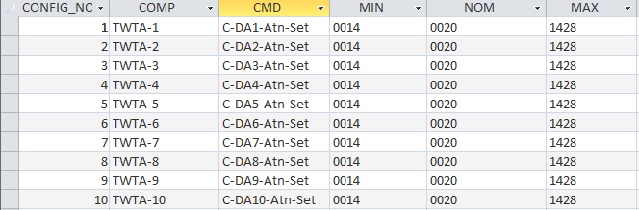
Table 4 Configuration based BOA database Table

3.2.1.3 Following is the database table for tele-command files
This table contains all payloadTC files existed in SCC. These files can be called from PCC for execution.
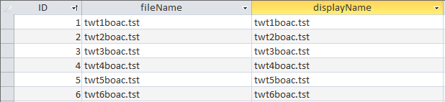
Table 5Telecommand files database table

Following is the database table for data commands
This table contains all the data-commands related to payload systems. A mapping table for all possible data values to user friendly name shall be defined (Table 7) to ease user selection from GUI.
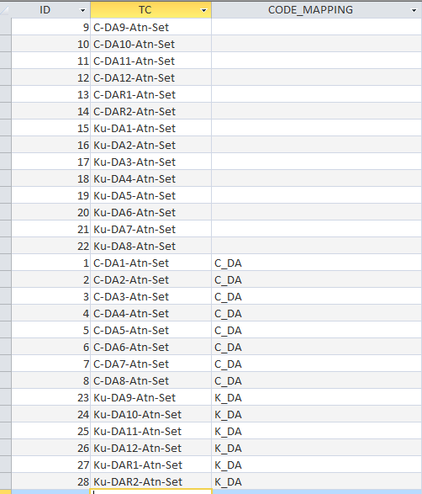

Table 6 Data commands Database
q
Table 7 Data Commands Mapping Table

Following is the database table for configuration based commanding
This table contains all the tele-commands applicable for each configuration.
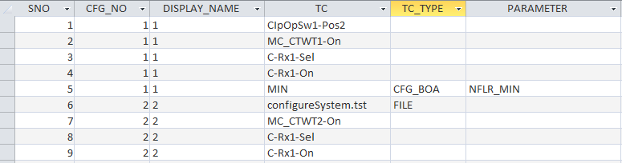
Table 8 Configuration based commanding database

Following is the database table for Spacecraft checkout computer details

Table 9 SCC Details

3.2.2 Provision to send tele-commands

The user shall have a provision to select one or multipletele-command mnemonics specified in TC column of database table (mentioned in section 3.2.1.1) from a dropdown list as shown in following image. After selection provision shall be there to generate tele-command test-procedure and trigger its execution.

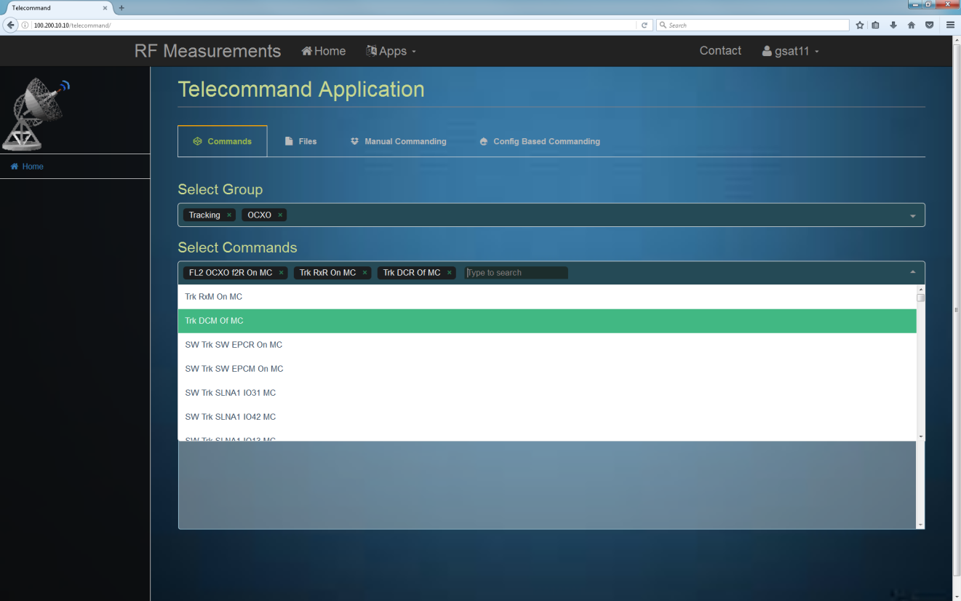
Figure 2GUI for Tele-commands Drop down

3.2.3 Provision to trigger file execution.

The user shall have a provision to select any one tele-command File specified in Filename column of database table (mentioned in section 3.2.1.3) from a dropdown list as shown in following image.After selection provision shall be there to trigger its execution.

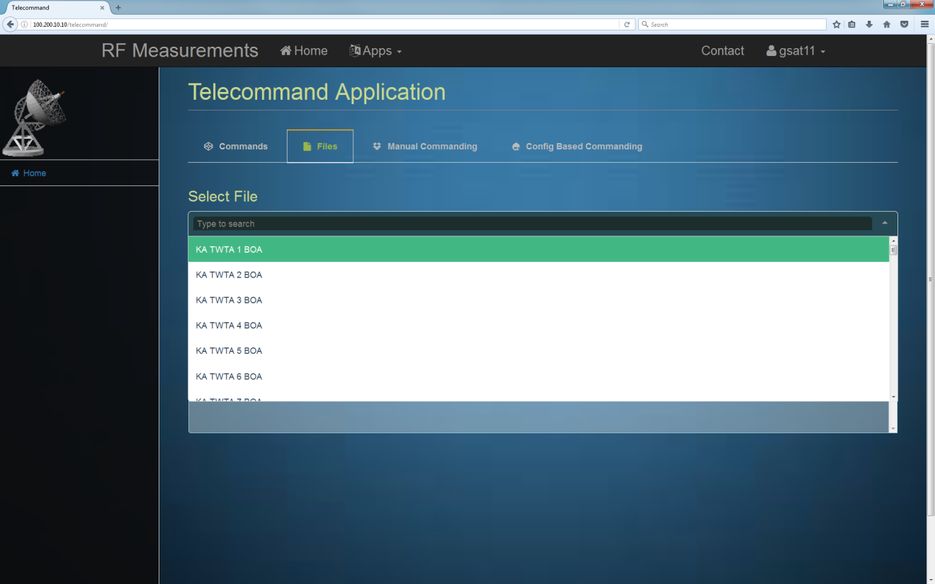
Figure 3 GUI for selecting Tele-command Files

3.2.4 Provisionto send configuration based BOA.

The user shall have provision to select one or multiple required BOA data command specified indatabase table (mentioned in section 3.2.1.2) from a dropdown list as shown in following image. After selection provision shall be there to generate tele-command test-procedure and trigger its execution.

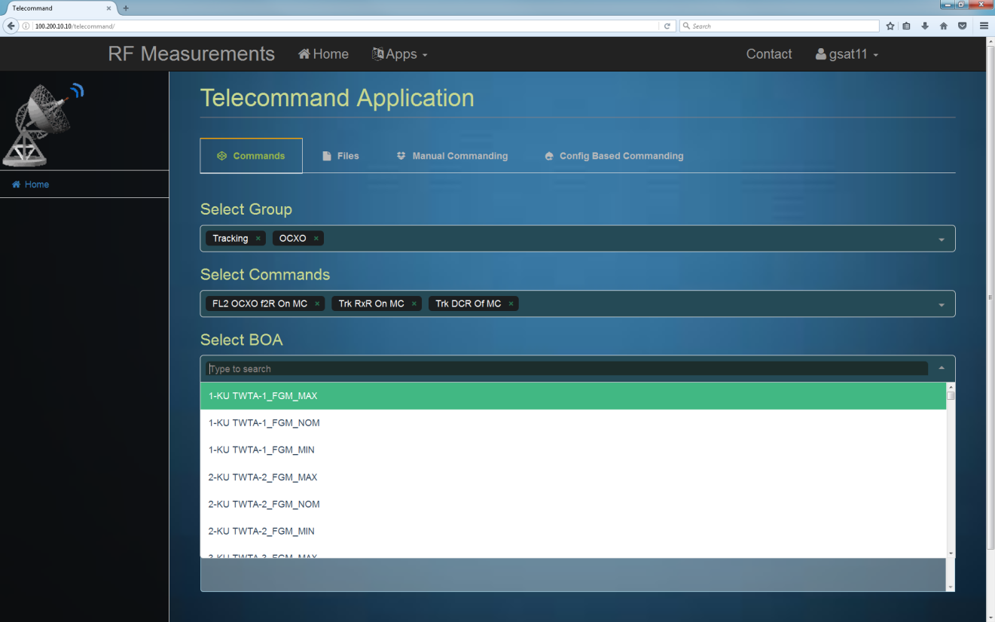
Figure 4GUI for selecting BOA commands

3.2.5 Provision to send required BOA manually.

The user shall have a provision to select any one required data command and enter data part of the command manually or a drop down has to come if a mapping exists for the selected data-command . Data commands mnemonics will be specified in database table (mentioned in section 3.2.1.4) which are displayed in a dropdown list as shown in following image.After selection provision shall be there to generate tele-command test-procedure and trigger its execution.

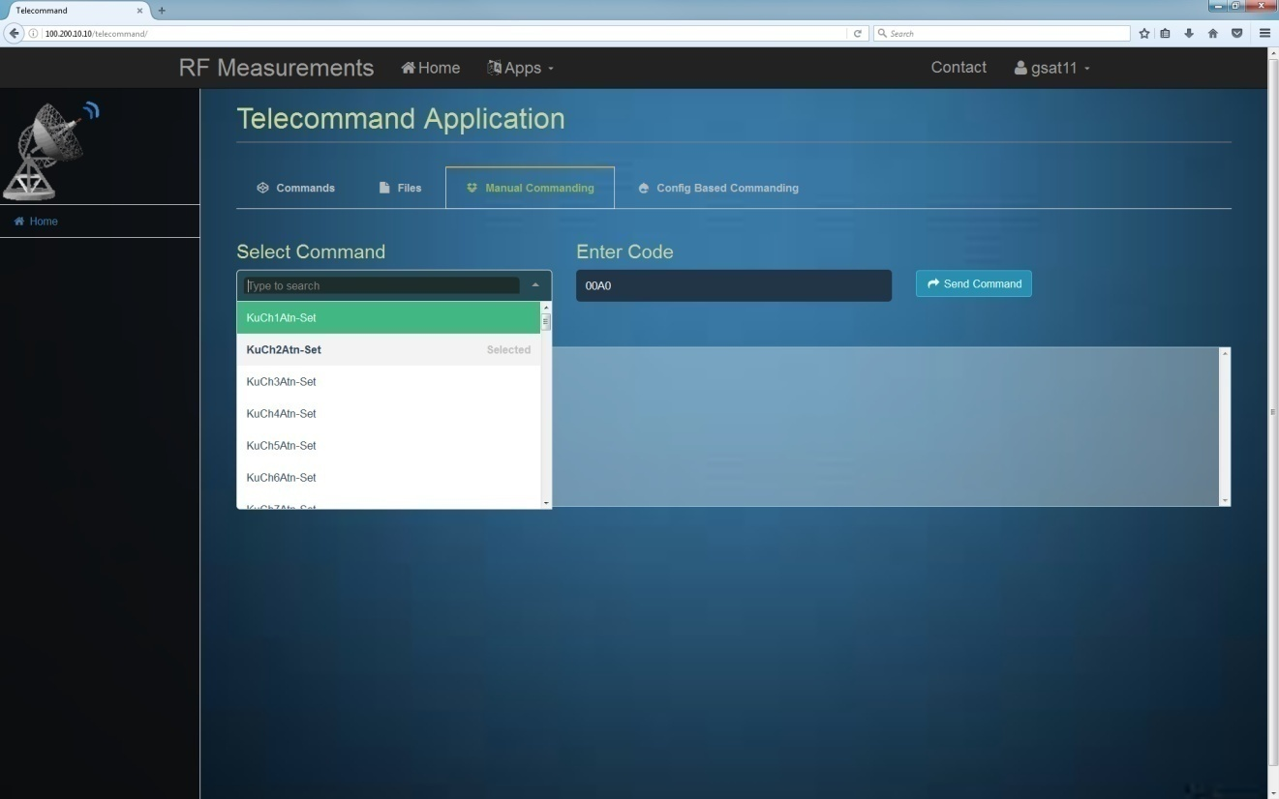
Figure 5GUI for Sending Data commands

3.2.6 Provision to send configuration based commands.

The user shall have a provision to enter configuration number, to select only switch commands, to select BOA and to select test parameter as shown in following image. Software shallgenerate test procedure with proper sequencing. In case of TM data break it shall alert the user.
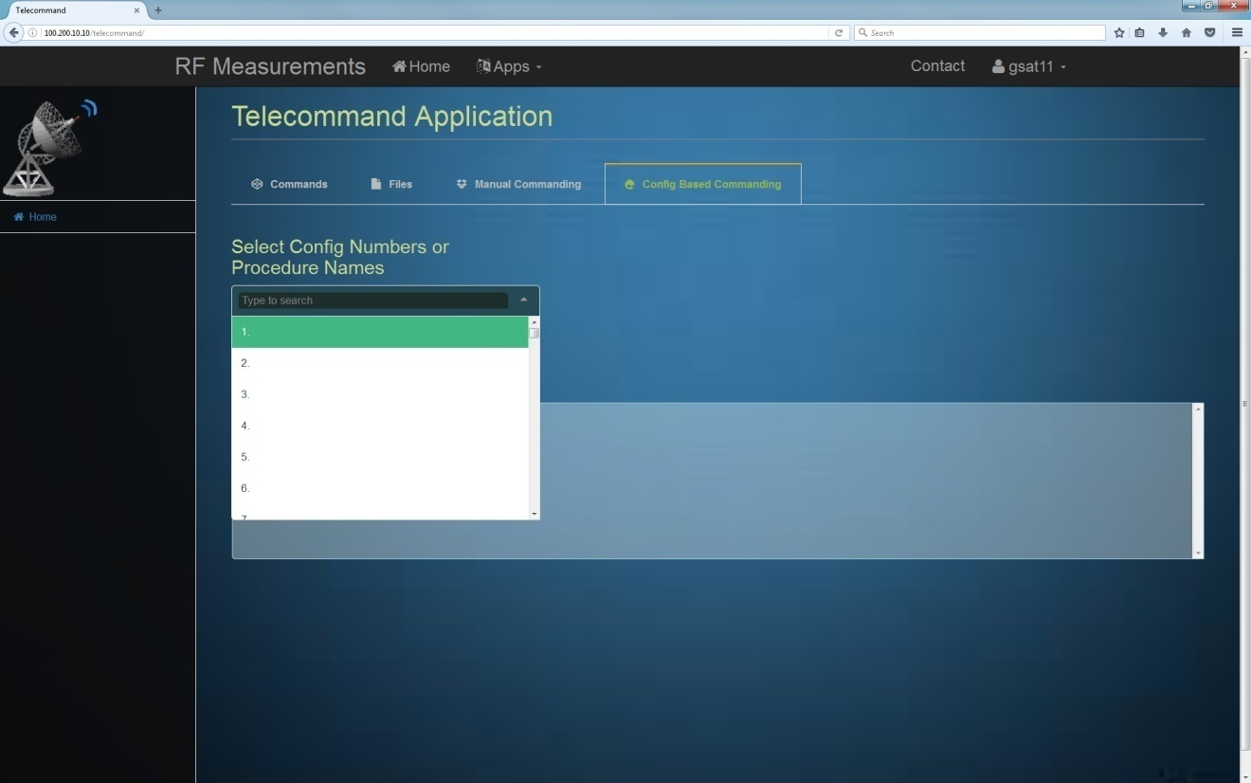
Figure 6GUI for sending configuration based commands

3.2.7 Search option to select commands or files

The user shall be able to search commands/file names from the dropdown list for all the cases shown above (section 3.2.2 to 3.2.6).

3.2.8 Provision should be there for command grouping

The user shall be able to select a commands group, based on this selection a dropdown list will be populated with commands corresponding to the group selected.

3.2.9Application should be accessible from any PC in the network

The application shall be accessible from any PC in the network. This is to allow user to work remotely.

3.2.10 Safe re-configuration of payload from any current state to any another state shall be available. On/off sequencing shall be taken care.

The user shall be able to safely re-configure payload from any current state to any other state. The software shall have intelligence for configuring payload. It shall take care of command on/off sequencing.

3.2.11GUI interface shall be there to show current state of payload with switching complexity to change from current payload configurations to new configurations.

User interface shall be there to check current payload status along with switching complexity to re-configure payload from current state to any other state.

3.2.12Provision shall be there to generate test procedures document.

The user shall be able to generate test procedures document for all payload configurations defined in database.

3.2.13Provision shall be there to exclude on commands while configuring the payload.

The user shall have a provision to exclude on commands in generated test procedure while re-configuring payload.

3.2.14Provision shall be there to set configuration based on test parameter.

The user shall have a provision to configure payload based on test-parameter, Based on select test parameter additional commands required for that test shall be issued.

3.2.15Provision shall be there to include call files along with other commands while setting configuration.

The user shall have an option to call any file/procedure either resident at SCC or at PCC while generating the test procedure file. User can create a file and invoke it using Smart TC along with other commands of configuration.

3.2.16Provision shall be there to inhibit tele-commands.

The user shall have an option to inhibit tele-commands. During payload characterization there may be some elements of the payload which are either not mounted or failed. Such systems are prohibited from turning on. So, inhibit option to be included in Smart TC which will inhibit the particular system from being turned ON.

3.2.17Provision shall be there to limit the number of TWTAs /SSPAs to be switched on based on current limit and/or thermal requirement.

There shall be logic in Smart TC to limit the number of TWTAs /SSPAs to be switched on based on current limit and/or thermal requirement.
BAS current limit is set by the main frame team. Based on this limit, software should be able to limit maximum number of TWTs/SSPAs that can be turned ‘ON’ such that BAS current limit is not crossed. And similar logic to be provided to handle thermal constraint

3.2.18Provision shall be there to keep adjacent channels at maximum BOA.

During payload characterization, the standard practice involves putting adjacent channels at MAX BOA. Smart TC can take this into account and generate telecommands comprising of adjacent TWTA/SSPA at max BOA.

3.2.19 Provision to generate incremental procedure files

During payload reconfiguration, sequence of commands to be followed strictly.
For example TWTA can be turned on only if switches are configured.
Sample Procedure:
EXPECTED twt1-sw-io-pos=pos13
SEND twt1-sw-io-pos13
EXPECTED twt1-sts=on
SEND twt1-on
In above procedure, if expected for the first command fails then the rest of the commands should not be sent.

This approach creates problem for some kind payloads which uses multiplexed telemetry with different sampling time (More than one master frame 32sec). As ACSS waits for 32sec before checking expected telemetry if sampling time is more than 32sec expected will fail before telemetry change happens.

To address this problem, the procedure can be split into multiples files without expected command, the telemetry check has to happen at PCC side for each command before generating the next command sequence. i.e for above sample procedure first command will be issued without expected value later after expected telemetry occurs next twta on command will is issued. The software has to wait for telemetry change based on its sampling time , if telemetry not changed after sampling time software has to alert user regarding anamoly and terminate the next configuration sequence.

3.2.20 Provision to cater GISAT Data transmitter Payload Test Requirement

- GISAT Data Transmitter contains BSU-M, BSU-R, 16 transmit module having 4 SSPAs each, DA-M, DA-R, LOUC-M, LOUC-R, DHE-M and DHE-R.
- To turn on GISAT payload procedure is explained below in flow chart

- Procedure to configure Configuration 1(MAIN CONFIG)

START
Configure BSU
Send BEPC-M-ON
Check BSU-FPGA-STS = Done
Send ThrComp-Dis
Phase-Comp-BPSS
Perform subsystem selection
send Ku-UC-DA-M-Sel
send QPSK-MOD-M-Sel
ISOLATErequired TX module
Call TX-MOD1-ON.tst
Send Jump-Default

Turn on the EPC
Send ALL-EPC-ON
A
G
O

Check Telemetry
KU1-4-EPC-STS = ON
DA-M-EPC-STS = ON
LOUC-M-EPC-STS= ON
A
SET DA GAIN AND PHASE
SEND PH-GAIN-Data-DA 0006
CALL ph4.tst
CALL ph5.tst
CALL phase6.tst
send PH-GAIN-DATA
Configure on board modulator
SEND DC-DC-M-SEL
SEND PLC-M-ON
SEND ATM-1-ON
SEND ATM-2-ON
Wait 128 sec
Check Telemetry
HSW-PLC-M-Sts = ON
D
Turn on Modulator
DHE-EPC-M-ON
WAIT 30 seconds
send MOD-FPGA-Rst
Wait 128 sec
Check Telemetry
PLCDHE-EPCM-Sts = ON
QPSK-MOD-M-Sts = Mod-ON

Turn off modulation
Send QPSK-MOD-On-Of
Check Telemetry
QPSK-MOD-M-Sts = Mod-off
Perform Cw measurements
Turn on modulation *perform modulated mesaurements
E
F
E
Do u want to perform test in same Tx module?
Check Telemetry
KU1-4-EPC-STS = ON
DA-M-EPC-STS = ON
LOUC-M-EPC-STS= ON
F
Call files for next cfg in same module
CALL ph4.tst
CALL ph5.tst
CALL phase6.tst
send PH-GAIN-DATA
G
Turn off the system
Send Dhe-epc-outoff
Send all-epc-of

Wait 128 sec
Check Telemetry
PLCDHE-EPCM-Sts = OFF
KU1-4-EPC-STS = OFF
DA-M-EPC-STS = OFF
LOUC-M-EPC-STS= OFF

Do u want to perform test in next Tx module?
Do u want to changeover from main to redt?
H
STOP
Turn off the system
Send Dhe-epc-outoff
Send all-epc-of
SEND bepc-m-off

- Procedure to configure Configuration 73(REDT CONFIG)
Configure BSU
Send BEPC-R-ON
Check BSU-FPGA-STS = Done
Send ThrComp-Dis
Phase-Comp-BPSS
Perform subsystem selection
send Ku-UC-DA-R-Sel
send QPSK-MOD-R-Sel
ISOLATE required TX module
Call TX-MOD1-ON.tst
Turn on the EPC
Send ALL-EPC-ON
Send Jump-Default

i
N
H
Check Telemetry
KU1-4-EPC-STS = ON
DA-R-EPC-STS = ON
LOUC-R-EPC-STS= ON
i
SET DA GAIN AND PHASE
SEND PH-GAIN-Data-DA 0006
CALL ph4.tst
CALL ph5.tst
CALL phase6.tst
send PH-GAIN-DATA
Configure on board modulator
SEND DC-DC-R-SEL
SEND PLC-R-ON
SEND ATM-1-ON
SEND ATM-2-ON
Wait 128 sec
Check Telemetry
HSW-PLC-R-Sts = ON

K
Turn on Modulator
DHE-EPC-R-ON
WAIT 30 seconds
send MOD-FPGA-Rst
Wait 128 sec
Check Telemetry
PLCDHE-EPCR-Sts = ON
QPSK-MOD-R-Sts = Mod-oN

Turn off modulation
Send QPSK-MOD-On-Of
Check Telemetry
QPSK-MOD-R-Sts = Mod-off
Perform Cw measurements
Turn on modulation *perform modulated mesaurements
L
M
L
Do u want to perform test in same Tx module?
Check Telemetry
KU1-4-EPC-STS = ON
DA-R-EPC-STS = ON
LOUC-R-EPC-STS= ON
M
Call files for next cfg in same module
CALL ph4.tst
CALL ph5.tst
CALL phase6.tst
send PH-GAIN-DATA
N
Turn off the system
Send Dhe-epc-outoff
Send all-epc-of

Wait 128 sec
Check Telemetry
PLCDHE-EPCR-Sts = OFF
KU1-4-EPC-STS = OFF
DA-R-EPC-STS = OFF
LOUC-R-EPC-STS= OFF

Do u want to perform test in next Tx module?
Do u want to changeover from REDT to MAIN?
O
STOP
Turn off the system
Send Dhe-epc-outoff
Send all-epc-of
SEND bepc-r-off

- WITH SINGLE TRANSMIT MODULE ON.
CW Measurement = Power, Frequency, spurious
Modulated measurement = Channel Power, RF Spectrum plot

STEP-1: For measurement of CFG-1 Following set of Commands need to be sent.
expected BSU-EPC-M-Sts = ON
send BEPC-M-ON( To turn on main Beam steering unit)
Expected BSU-FPGA-STS = Done
Common for cfg 1-64
Send Jump-Default (FPGA will jump at default address)
SendThrComp-Dis // During Th-VAC send ThrComp-Ena
Send Phase-Comp-BPSS( To bypass onboard lookup table of phase and gain)
expected LOUC-SEL-STS = Main
send Ku-UC-DA-M-Sel( To select main upconverter and DA)
expected MOD-SEL-STS = Main
send QPSK-MOD-M-Sel (To select main modulator)
// This call file is used to select Single Transmit Module
CALL TX-MOD1-ON.tst ( This file contains details of TX module to be selected to turn on)
expected KU1-4-EPC-STS = ON;
DA-M-EPC-STS = ON;
LOUC-M-EPC-STS= ON
send ALL-EPC-ON( it will turn on EPCs of all selected TX module, DA and LOUC)
SEND PH-GAIN-Data-DA 0006
CALL 106-2-c1.tst (This file contains details of BOA and PHASE of SSPA’s 1-32)
CALL ph5-00-3364.tst (This file contains details of BOA and PHASE of SSPA’s 33-64)
CALL phase6.tst (common file to be send for all configuration after above two files)
send PH-GAIN-DATA (To apply BOA and PHASE data)
SEND DC-DC-M-SEL (main DC-DC supply selection)
EXPECTED HSW-PLC-M-Sts = ON// from here onwards telemetry will update in 128 sec approx.
SEND PLC-M-ON (To turn on payload controller)
EXPECTED ATM-1-Sts = ON
SEND ATM-1-ON (To turn on analog telemetry module-1)
EXPECTED ATM-2-Sts = ON
SEND ATM-2-ON (To turn on analog telemetry module-2)
EXPECTED PLCDHE-EPCM-Sts = ON
SEND DHE-EPC-M-ON ( to turn on main data handling electronics)
Wait 30 sec
Check QPSK-MOD-M-Sts = Mod-on
If mod is on then proceed with second step
Step-2 : Perform all the modulated measurement here( Channel Power, RF SPECTRUM PLOT)
Step-3 :After this for CW Measurement send following Command
ExpectedQPSK-MOD-M-Sts = Mod-off
send QPSK-MOD-On-Of
perform all CW measurement here

3.2.20.1 Details of TX module file
Tx-MOD1ON file
It consist details of Tx module to be selected to turn on as follows

000.001 select segid c8 - FIXED
000.002 select cmdmodemsgtable - FIXED
000.003 sendlistData_word 0001 ; ! No of Patch pkts! - FIXED
Data_word 6051 ; ! CMD WORD1 ! - FIXED
TX module 1 is selected to turn on
Data_word 0000 ; !DATA WORDS!
Data_word 0019 ;
Data_word 0019 ;
Data_word 0019 ;
Data_word 0019 ;
Data_word 0019 ;
Data_word 0019 ;
Data_word 0019 ;
TX module 2-16 are isolated
Data_word 0019 ;
Data_word 0019 ;
Data_word 0019 ;
Data_word 0019 ;
Data_word 0019 ;
Data_word 0019 ;
Data_word 0019 ;
Data_word 0019 ;
Data_word 0055
000.004 select cmdmode normal
000.005 singlestep
000.006 end

- Data word 0000 is for selection and data word 0019 is for isolation
- Multiple TX module selection for Turn-on is possible by giving multiple data word 0000 on respective locations based on TX module number

3.2.20.2 Details of BOA and PHASE file for SSPA 1-32
000.001 select segid c8- FIXED
000.002 select cmdmodemsgtable- FIXED
000.003 sendlistData_word 0001 ;- FIXED
Data_word 6080 ; ! CMD WORD1 !- FIXED
Data_word 0413 ; !DATA WORDS!
BOA and PHASE details of SSPA 1
Data_word 1F00 ;
Data_word 1F00 ;
Data_word 1F00 ;
Data_word 1F00 ;
Data_word 1F00 ;
Data_word 1F00 ;
Data_word 1F00 ;
Data_word 1F00 ;
Data_word 1F00 ;
Data_word 1F00 ;
Data_word 1F00 ;
BOA and PHASE details of SSPA 2-32
Data_word 1F00 ;
Data_word 1F00 ;
Data_word 1F00 ;
Data_word 1F00 ;
Data_word 1F00 ;
Data_word 1F00 ;
Data_word 1F00 ;
Data_word 1F00 ;
Data_word 1F00 ;
Data_word 1F00 ;
Data_word 1F00 ;
Data_word 1F00 ;
Data_word 1F00 ;
Data_word 1F00 ;
Data_word 1F00 ;
Data_word 1F00 ;
Data_word 1F00 ;
Data_word 1F00 ;
Data_word 1F00 ;
Data_word 1F00
000.004 select cmdmode normal- FIXED
000.005 singlestep- FIXED
000.006 end- FIXED

- Data word 0413 BOA and PHASE is assigned to SSPA-1
- DATA word 1F00 maximum BOA and 0 PHASE is assigned to all other 2-32 SSPAs
- Above example is for configuration number-1 (SSPA-1)
- In configuration defined BOA and PHASE need to send for respective SSPA and rest SSPAs will be at 1F00.

3.2.20.3 Details of BOA and PHASE file for SSPA 33-64 file
000.001 select segid c8- FIXED
000.002 select cmdmodemsgtable- FIXED
000.003 sendlistData_word 0001 ;- FIXED
Data_word 60A0 ; ! CMD WORD1 !- FIXED
Data_word 0413 ; !DATA WORDS!
BOA and PHASE details of SSPA 33
Data_word 1F00 ;
Data_word 1F00 ;
Data_word 1F00 ;
Data_word 1F00 ;
Data_word 1F00 ;
Data_word 1F00 ;
Data_word 1F00 ;
Data_word 1F00 ;
Data_word 1F00 ;
Data_word 1F00 ;
Data_word 1F00 ;
Data_word 1F00 ;
BOA and PHASE details of SSPA 33-64
Data_word 1F00 ;
Data_word 1F00 ;
Data_word 1F00 ;
Data_word 1F00 ;
Data_word 1F00 ;
Data_word 1F00 ;
Data_word 1F00 ;
Data_word 1F00 ;
Data_word 1F00 ;
Data_word 1F00 ;
Data_word 1F00 ;
Data_word 1F00 ;
Data_word 1F00 ;
Data_word 1F00 ;
Data_word 1F00 ;
Data_word 1F00 ;
Data_word 1F00 ;
Data_word 1F00 ;
Data_word 1F00
000.004 select cmdmode normal- FIXED
000.005 singlestep- FIXED
000.006 end- FIXED

- Data word 0413 BOA and PHASE is assigned to SSPA-33
- DATA word 1F00 maximum BOA and 0 PHASE is assigned to all other 34-64 SSPAs
- Above example is for configuration number-33(SSPA-33)
- In configuration defined BOA and PHASE need to send for respective SSPA and rest SSPAs will be at 1F00.
3.2.20.4 Details of common file need to send with above two files

000.001 select segid c8
000.002 select cmdmodemsgtable
Fixed for all configuration
000.003 sendlistData_word 0001 ;
Data_word 60C0 ; ! CMD WORD1 !
Data_word 0055
000.004 select cmdmode normal
000.005 singlestep
000.006 end

For Changover FROM CFG-1 to CFG-2

Step1: Send following set of files to changeover from CFG1 to CFG2
CALL 90-1-c2.tst
CALL ph5-00-3364.tst
CALL phase6.tst
Step 2: Send following set of commands
send PH-GAIN-DATA
Check QPSK-MOD-M-Sts = Mod-on
Step-3 : Perform all the modulated measurement here( Channel Power, RF SPECTRUM PLOT)
Step-4 :After this for CW Measurement send following Command
ExpectedQPSK-MOD-M-Sts = Mod-off
send QPSK-MOD-On-Of
perform all CW measurement here

For Changover FROM CFG-2 to CFG-3

Step1: Send following set of files to changeover from CFG2 to CFG3
CALL 90-1-c4.tst
CALL ph5-00-3364.tst
CALL phase6.tst
Step 2: Send following set of commands
send PH-GAIN-DATA
Check QPSK-MOD-M-Sts = Mod-on
Step-3 : Perform all the modulated measurement here( Channel Power, RF SPECTRUM PLOT)
Step-4 :After this for CW Measurement send following Command
ExpectedQPSK-MOD-M-Sts = Mod-off
send QPSK-MOD-On-Of
perform all CW measurement here

For Changover FROM CFG-3 to CFG-4

Step1: Send following set of files to changeover from CFG3 to CFG4
CALL 90-1-c4.tst
CALL ph5-00-3364.tst
CALL phase6.tst
Step 2: Send following set of commands
send PH-GAIN-DATA
Check QPSK-MOD-M-Sts = Mod-on
Step-3 : Perform all the modulated measurement here( Channel Power, RF SPECTRUM PLOT)
Step-4 :After this for CW Measurement send following Command
ExpectedQPSK-MOD-M-Sts = Mod-off
send QPSK-MOD-On-Of
perform all CW measurement here

For Changover FROM CFG-4 to CFG-5(IF one Tx module is on)

In CFG-5 changeover from transmit module 1 (TX-MOD1) to transmit module 2(TX-MOD2) is done. Following are the set of commands needs to be send.

Step1: Put off DHE-EPC, U/C Main , DA Main and TX-MOD1 (contains SSPA1 to SSPA4).
EXPECTED PLCDHE-EPCM-Sts= OF
sendDHE-EPC-OutOFF
expectedKU1-4-EPC-STS = OFF;
KU5-8-EPC-STS = OFF;
KU1-4-EPC-STS = OFF;
KU5-8-EPC-STS = OFF;
KU9-12-EPC-STS = OFF;
KU13-16-EPC-STS = OFF;
KU17-20-EPC-STS = OFF;
KU21-24-EPC-STS = OFF;
KU25-28-EPC-STS = OFF;
KU29-32-EPC-STS = OFF;
KU33-36-EPC-STS = OFF;
KU37-40-EPC-STS = OFF;
KU41-44-EPC-STS = OFF;
KU45-48-EPC-STS = OFF;
KU49-52-EPC-STS = OFF;
KU53-56-EPC-STS = OFF;
KU57-60-EPC-STS = OFF;
KU61-64-EPC-STS = OFF;
DA-M-EPC-STS = OFF;
LOUC-M-EPC-STS= OFF
sendALL-EPC-OF

Step2: Select Transmit module2(TX-MOD2,contains SSPA5 to SSPA8) and proceed with following commanding.
CALL TX-MOD2-ON.tst
expected KU5-8-EPC-STS = ON;
DA-M-EPC-STS = ON;
LOUC-M-EPC-STS= ON
send ALL-EPC-ON
SEND PH-GAIN-Data-DA 0006
CALL 106-2-c5.tst
CALL ph5-00-3364.tst
CALL phase6.tst
send PH-GAIN-DATA
EXPECTED PLCDHE-EPCM-Sts = ON
SEND DHE-EPC-M-ON
Wait 30 sec
Check QPSK-MOD-M-Sts = Mod-on
If mod is on then proceed with third step
Step-3 : Perform all the modulated measurement here( Channel Power, RF SPECTRUM PLOT)
Step-4 :After this for CW Measurement send following Command
ExpectedQPSK-MOD-M-Sts = Mod-off
send QPSK-MOD-On-Of
perform all CW measurement here.

- For CFG 6 to 8 (SSPA 6 to SSPA 8) follow the procedure of Change over like CFG 1 to 2, 2 to 3 and CFG 3 to 4.
- For next Transmit module 3(TX-MOD3) onwards follow the same procedure as above mentioned.

- WITH ALL TRANSMIT MODULE ON.
CW Measurement = Power, Frequency, spurious
Modulated measurement = Channel Power, RF Spectrum plot
STEP-1: For measurement of CFG-1 Following set of Commands need to be sent.
expected BSU-EPC-M-Sts = ON
send BEPC-M-ON
Wait 7 sec
Expected BSU-FPGA-STS = Done
Send Jump-Default
SendThrComp-Dis // During Th-VAC send ThrComp-Ena
Send Phase-Comp-BPSS
expected LOUC-SEL-STS = Main
send Ku-UC-DA-M-Sel
expected MOD-SEL-STS = Main
send QPSK-MOD-M-Sel
// This call file is used to select ALL Transmit Module
CALL TX-ALL-ON.tst
expected KU1-4-EPC-STS = ON;
KU5-8-EPC-STS = ON;
KU1-4-EPC-STS = ON;
KU5-8-EPC-STS = ON;
KU9-12-EPC-STS = ON;
KU13-16-EPC-STS = ON;
KU17-20-EPC-STS = ON;
KU21-24-EPC-STS = ON;
KU25-28-EPC-STS = ON;
KU29-32-EPC-STS = ON;
KU33-36-EPC-STS = ON;
KU37-40-EPC-STS = ON;
KU41-44-EPC-STS = ON;
KU45-48-EPC-STS = ON;
KU49-52-EPC-STS = ON;
KU53-56-EPC-STS = ON;
KU57-60-EPC-STS = ON;
KU61-64-EPC-STS = ON;
DA-M-EPC-STS = ON;
LOUC-M-EPC-STS= ON
send ALL-EPC-ON
SEND PH-GAIN-Data-DA 0006
CALL 106-2-c1.tst
CALL ph5-00-3364.tst
CALL phase6.tst
send PH-GAIN-DATA
SEND DC-DC-M-SEL
EXPECTED HSW-PLC-M-Sts = ON// from here onwards telemetry will update in 128 sec approx.
SEND PLC-M-ON
EXPECTED ATM-1-Sts = ON
SEND ATM-1-ON
EXPECTED ATM-2-Sts = ON
SEND ATM-2-ON
EXPECTED PLCDHE-EPCM-Sts = ON
SEND DHE-EPC-M-ON
Wait 30 sec
Check QPSK-MOD-M-Sts = Mod-on
If mod is on then proceed with second step
Step-2 : Perform all the modulated measurement here( Channel Power, RF SPECTRUM PLOT)
Step-3 :After this for CW Measurement send following Command
ExpectedQPSK-MOD-M-Sts = Mod-off
send QPSK-MOD-On-Of
perform all CW measurement here

For Changover FROM CFG-1 to CFG-2

Step1: Send following set of files to changeover from CFG1 to CFG2
CALL 90-1-c2.tst
CALL ph5-00-3364.tst
CALL phase6.tst
Step 2: Send following set of commands
send PH-GAIN-DATA
Check QPSK-MOD-M-Sts = Mod-on
Step-3 : Perform all the modulated measurement here( Channel Power, RF SPECTRUM PLOT)
Step-4 :After this for CW Measurement send following Command
ExpectedQPSK-MOD-M-Sts = Mod-off
send QPSK-MOD-On-Of
perform all CW measurement here
- Same procedure has to be followed for all 64 main combinations only respective call files for test cfg needs to be given.

For Changover FROM MAIN CFG’s to REDUNADANT CFG’s:

Main Configuration to redundant Configuration changeover, Following are the set of commands needs to be send.

Step1: Put off DHE-EPC, U/C Main, DA Main, Transmit Module(TX-MOD) and BSU Main.
EXPECTED PLCDHE-EPCM-Sts= OF
sendDHE-EPC-OutOFF
expectedKU1-4-EPC-STS = OFF;
KU5-8-EPC-STS = OFF;
KU1-4-EPC-STS = OFF;
KU5-8-EPC-STS = OFF;
KU9-12-EPC-STS = OFF;
KU13-16-EPC-STS = OFF;
KU17-20-EPC-STS = OFF;
KU21-24-EPC-STS = OFF;
KU25-28-EPC-STS = OFF;
KU29-32-EPC-STS = OFF;
KU33-36-EPC-STS = OFF;
KU37-40-EPC-STS = OFF;
KU41-44-EPC-STS = OFF;
KU45-48-EPC-STS = OFF;
KU49-52-EPC-STS = OFF;
KU53-56-EPC-STS = OFF;
KU57-60-EPC-STS = OFF;
KU61-64-EPC-STS = OFF;
DA-M-EPC-STS = OFF;
LOUC-M-EPC-STS= OFF
sendALL-EPC-OF
SendThrComp-Dis
expected BSU-EPC-M-Sts = OFF
send BEPC-M-OFF
send atmboth-0ff
send plc-off
STEP-2: For measurement of CFG-73 Following set of Commands need to be sent.
expected BSU-EPC-R-Sts = ON
send BEPC-R-ON
Wait 7 sec
Expected BSU-FPGA-STS = Done
Send Jump-Default
SendThrComp-Dis // During Th-VAC send ThrComp-Ena
Send Phase-Comp-BPSS
expected LOUC-SEL-STS = Redt
send Ku-UC-DA-R-Sel
expected MOD-SEL-STS = Redt
send QPSK-MOD-R-Sel

Step 3: Select Transmit module1(TX-MOD1, contains SSPA1 to SSPA4) and proceed with following commanding.
CALL TX-MOD1-ON.tst
expected KU1-4-EPC-STS = ON;
DA-R-EPC-STS = ON;
LOUC-R-EPC-STS= ON
send ALL-EPC-ON
SEND PH-GAIN-Data-DA 0006
CALL 106-2-c73.tst
CALL ph5-00-3364.tst
CALL phase6.tst
send PH-GAIN-DATA
SEND DC-DC-R-SEL
EXPECTED HSW-PLC-R-Sts = ON// from here onwards telemetry will update in 128 sec approx.
SEND PLC-R-ON
EXPECTED ATM-1-Sts = ON
SEND ATM-1-ON
EXPECTED ATM-2-Sts = ON
SEND ATM-2-ON
EXPECTED PLCDHE-EPCR-Sts = ON
SEND DHE-EPC-R-ON
Wait 30 sec
Check QPSK-MOD-R-Sts = Mod-on
If mod is on then proceed with second step
Step-2 : Perform all the modulated measurement here( Channel Power, RF SPECTRUM PLOT)
Step-3 :After this for CW Measurement send following Command
Expected QPSK-MOD-R-Sts = Mod-off
send QPSK-MOD-On-Of
perform all CW measurement here.

For redundant 64 cfg follow the same procedure as per the main cfg’s.

3.2.21 Provision for test phase based commanding.
The user shall have an optiontosend telecommands based on test phases.
Examples-
- Thr-comp-dis command need to be send in clean room IST phase
- Thr-comp-ena command need to be send in TVAC IST phase

3.3. Performance Requirements

- This package shall be able to run on a PC with RAM of 1 GB along with other packages of COMPACSS.

3.4. Design Constraints

- The software interfaces are fixed as the interface at SCC should not get affected.

3.5. Software System attributes

Reliability Software reliability is the probability of failure free software operation for a specified period of time in a specified environment. To increase the reliability aspects, this software shall undergo proper verification & validation with exhaustive test cases to cover all possibilities of errors

Availability Proper and systematic back-up and recovery features to be planned to increase the availability of the software

Maintainability The software shall follow data driven approach to cater to easy maintenance across different projects and varying requirements in the future

Tele-command software Goals:

- To configure the Payload as per user/test requirements by generation of telecommand(s) files dynamically in CCL-compliant format from PCC &placing requests to SCC forexecution of the same.
- Payload Safety shall be ensured throughout the process of commanding / re-configuration of the payload.
- Commanding/re-configuration of the payload shall take the minimum possible time
- Shall be user-friendly

Comparison of Featuresof all versions of TelecommandApplication

Comparison of Features
Feature | V1.0 | V2.0 | V2.1  (SMART TC) | Remarks
SendingTelecommands | Y | Y | Y
SendingTelecommand Files | Y | Y | Y
Sequential Switch Commanding | Y  (Macros are required) | Y | Y
Sending Configuration based BOA | N | Y | Y
Manual data commanding | N | Y | Y
Configuration based commanding | N | Y | Y
Incremental commanding | N | Y | N | This feature not required now.
Commands Grouping | N | Y | Y
Commands Search Capability | N | Y | Y
VEPW Commanding | N | Y | Y
Commanding Inelegance(Safe re-configuration of payload from any current state to any other state) | N | N | Y
Test parameter based commanding | N | N | Y
Tele-Command Inhibit Option | N | N | Y
Call files along with configuration based commands | N | N | Y
Display of current state of payload with switching complexity. | N | N | Y
Generation of test procedures document | N | N | Y
Exclude ‘ON’commands while configuring the payload | N | N | Y
Limiting the number of TWTAs /SSPAs to be switched ‘ON’ based on current limit and/or thermal requirement | N | N | Y
Provision to keep adjacent channels at maximum BOA | N | N | Y

Table 11Features Comparison

Requirements Traceability Matrix

Software Requirement Id | Section | System Requirement Id | Section | Description
RID 1 | 3.2.1 |  |  | Database tables for tele-commands
RID 2 | 3.2.2 |  |  | Provision should be there to send tele-commands.
RID 3 | 3.2.3 |  |  | Provision should be there to trigger file execution.
RID 4 | 3.2.4 |  |  | Provision should be there to send configuration based BOA.
RID 5 | 3.2.5 |  |  | Provision should be there to send required BOA manually.
RID 6 | 3.2.6 |  |  | Provision should be there to send configuration based commands.
RID 7 | 3.2.7 |  |  | Search option should be there to select commands or files.
RID 8 | 3.2.8 |  |  | Commands grouping option should be available.
RID 9 | 3.2.9 |  |  | Application should be accessible from any PC in the network.
RID 10 | 3.2.9 |  |  | Application should be accessible from any PC in the network.
RID 11 | 3.2.10 |  |  | Safe re-configuration of payload from any current state to any another state shall be available. On/off sequencing shall be taken care
RID 12 | 3.2.11 |  |  | GUI interface shall be there to show current state of payload with switching complexity to change from current payload configurations to new configurations
RID 13 | 3.2.12 |  |  | Provision shall be there to generate test procedures document.
RID 14 | 3.2.13 |  |  | Provision shall be there to exclude on commands while configuring the payload
RID 15 | 3.2.14 |  |  | Provision shall be there to set configuration based on test parameter
RID 16 | 3.2.15 |  |  | Provision shall be there to include call files along with other commands while setting configuration
RID 17 | 3.2.16 |  |  | Provision shall be there to inhibit tele-commands.
RID 18 | 3.2.17 |  |  | Provision shall be there to limit the number of TWTAs /SSPAs to be switched on based on current limit and/or thermal requirement.
RID 18 | 3.2.18 |  |  | Provision shall be there to keep adjacent channels at maximum BOA
Table 10Requirements Traceability

